**ASSIGNMENT 1 FRONT SHEET**

|  |  |  |  |
| --- | --- | --- | --- |
| **Qualification** | **BTEC Level 5 HND Diploma in Computing** | | |
| **Unit number and title** | **Unit 17: Business Process Support** | | |
| **Submission date** |  | **Date Received 1st submission** |  |
| **Re-submission Date** |  | **Date Received 2nd submission** |  |
| **Student Name** | Nguyen Thi Huyen Trang | **Student ID** | BH01280 |
| **Class** | SE06303 | **Assessor name** | Ta Quang Hieu |
| **Student declaration**  I certify that the assignment submission is entirely my own work and I fully understand the consequences of plagiarism. I understand that making a false declaration is a form of malpractice. | | | |
|  |  | **Student’s signature** | Hieu |

**Grading grid**

|  |  |  |  |  |  |  |
| --- | --- | --- | --- | --- | --- | --- |
| **P1** | **P2** | **P3** | **P4** | **M1** | **M2** | **D1** |
|  |  |  |  |  |  |  |

|  |  |  |
| --- | --- | --- |
| **❒ Summative Feedback: ❒ Resubmission Feedback:** | | |
| **Grade:** | **Assessor Signature:** | **Date:** |
| **Internal Verifier’s Comments:** | | |
| **Signature & Date:** | | |

Table of content

Table of figure

1. Introduction

ABC Manufacturing, a multinational leader in consumer electronics. Over the past three months as an intern, I have had the opportunity to engage in projects that connect clients with local and national datastores, emphasizing the transformative impact of data-driven decision-making on operational efficiency and effectiveness.

The focus of this report is to demonstrate how data and information support business processes and their value to organizations. By leveraging tools such as Power BI for data analysis and using ChatGPT for data extraction, I will illustrate how these technologies enhance decision-making in supply chain management. Accurate demand forecasting, informed by historical sales data, market trends, and customer preferences, enables ABC Manufacturing to optimize production and inventory levels, reduce costs, and improve customer satisfaction.

Additionally, the report will explore the generation and manipulation of data using Power BI to create meaningful insights that support business operations. It will assess the value of data and information for individuals and organizations, particularly in the context of real-world business processes.

The report will also address the social, legal, and ethical implications of using data to support business processes, including common threats to data and strategies to mitigate these threats at both personal and organizational levels. An analysis of the impact of data and information on real-world business processes will provide a comprehensive understanding of their significance and potential benefits.

Through detailed examples and analyses, this report aims to offer a thorough understanding of the strategic importance of data in enhancing business processes, drawing on my experiences and projects at ABC Manufacturing.

1. Content
2. Discuss the social legal and ethical implications of using data and information to support business processes.

The utilization of data and information to enhance business processes entails significant social, legal, and ethical considerations. It is crucial for organizations like ABC Manufacturing to understand and address these implications to ensure responsible and compliant practices. This discussion aims to define and analyze these implications in detail, highlighting specific issues and proposing viable solutions.

1. Social Impact

* Privacy Concerns:
* Description: Privacy concerns arise when organizations collect and analyze personal data without clear consent and adequate safeguards.
* Problem: Collecting personal data requires clear and transparent consent from customers. Failure to do so can violate their privacy rights and lead to legal issues.
* Proposed Solution: ABC Manufacturing should implement clear, understandable, and accessible data privacy policies. Customers should give explicit consent before data collection, and they should be provided with options to opt out. This will protect customer privacy and build trust.
* Consumer Trust:
* Description: Mishandling or misuse of data can diminish consumer trust.
* Problem: Lack of transparency and customer control over their data can harm organizational reputation and trustworthiness.
* Proposed Solution: ABC Manufacturing should maintain transparency and provide customers with control over their data. This can include clear notifications on how and why their data is used and giving them access and control over their own data.
* Social Impact of Data Analysis:
* Description: Data-driven decisions can lead to unfair resource distribution and increase social inequality.
* Problem: Uncontrolled decisions may exacerbate social inequalities.
* Analysis: Decisions based on data should be made fairly and transparently to avoid exacerbating social inequalities.
* Proposed Solution: ABC Manufacturing should ensure data-driven decisions are fair and transparent. This includes conducting social impact assessments and ensuring algorithms and analyses are unbiased.

1. Legal Impact

* Data Protection Laws:
* Description: Compliance with stringent data protection laws like GDPR and CCPA is mandatory.
* Problem: Non-compliance can lead to severe penalties and financial damages.
* Proposed Solution: ABC Manufacturing should stay updated with regulatory changes and ensure compliance with data protection laws. Regular audits should be conducted to ensure legal adherence.
* Intellectual Property Rights:
* Description: Issues arise when organizations use data without proper licenses or permissions, potentially violating intellectual property rights.
* Problem: Using external data without legal permissions can lead to legal disputes and reputational damage.
* Proposed Solution: ABC Manufacturing should ensure it has valid licenses to use external data and adhere to the terms of those licenses. Legal checks should be conducted to ensure compliance with intellectual property laws.
* Compliance with International Trade Regulations:
* Description: Legal obligations concerning the use of cross-border data include WTO rules and free trade agreements.
* Problem: Non-compliance with international trade regulations can hinder business operations and lead to legal challenges.
* Proposed Solution: ABC Manufacturing should establish processes and controls to ensure compliance with international trade regulations. This may include working with legal experts to understand and comply with cross-border data use regulations.

1. Ethical Implications

* Data Bias and Discrimination:
* Description: Analyzing data without addressing biases can lead to discriminatory outcomes.
* Problem: Ensuring fairness and equity in data-driven processes is crucial.
* Proposed Solution: ABC Manufacturing should use diverse datasets to ensure algorithms and analyses are unbiased. Regular reviews and assessments should be conducted to identify and eliminate bias, ensuring fair data-driven decisions.
* Data Security and Cybersecurity:
* Description: Protecting data from unauthorized access and breaches is vital.
* Problem: Inadequate security measures can lead to data breaches and significant financial and reputational damage.
* Proposed Solution: ABC Manufacturing should invest in advanced cybersecurity measures, including encryption, access controls, and system monitoring. Regular security assessments should be conducted to identify and address vulnerabilities. Incident response plans should be established to effectively handle data breaches and minimize damage.
* Ethical Considerations in Predictive Analytics:
* Description: Using data for predictive analytics may raise ethical concerns.
* Problem: Lack of transparency and customer consent in predictive analytics can lead to ethical dilemmas.
* Proposed Solution: ABC Manufacturing should ensure that predictive analytics and data-driven predictions are transparent and have customer consent. This includes providing clear information on how and why predictions are made and allowing customers to opt-out.
* Conclusion: ABC Manufacturing must carefully consider the social, legal, and ethical implications of using data and information to support business processes. By addressing privacy concerns, maintaining consumer trust, complying with data protection laws, respecting intellectual property rights, ensuring fairness in data analysis, and protecting data from security threats, the organization can effectively leverage data while upholding responsible and ethical practices. These efforts not only enhance operational efficiency but also build a strong and trustworthy reputation in the market.

1. Describe common threats to data and how they can be mitigated at on a personal and organisational level.

Data security is paramount in both personal and organizational contexts. As technology advances, so do threats to data integrity, security, and availability. This section identifies common threats to data and provides detailed strategies to mitigate these risks at both the individual and organizational levels.

1. Phishing Attacks

* Description: Phishing involves fraudulent attempts to obtain sensitive information such as usernames, passwords, and credit card details by pretending to be a trustworthy entity in electronic communication.
* Mitigation Strategies at Personal Level:
* Email Filtering: Use email filters to detect and block phishing attempts.
* Awareness Training: Stay educated on common phishing tactics and be cautious of unsolicited emails asking for sensitive information.
* Two-Factor Authentication (2FA): Enable 2FA on accounts to add an extra layer of security.
* Example: An individual receives an email from an unknown source requesting bank account information update. Instead of clicking on the link in the email, they verify with their bank directly and identify it as a phishing attempt. They report this email to their email service provider to prevent similar attempts.
* Mitigation Strategies at Organizational Level
* Employee Training: Conduct regular training sessions on how to recognize and report phishing emails.
* Secure Email Gateways: Implement secure email gateways to filter out potential phishing emails.
* Phishing Simulations: Regularly test employees with simulated phishing attacks to improve their vigilance
* Example: A Company conducts a phishing simulation and finds that 20% of employees clicked on a harmful link. They subsequently conduct training to raise awareness, and in the next test, the click rate reduces to 5%.

1. Malware and Ransomware

* Description: Malware includes viruses, worms, and ransomware designed to harm or gain unauthorized access to systems.
* Mitigation Strategies at Personal Level:
* Antivirus Software: Install and regularly update antivirus software to detect and remove malware.
* Regular Backups: Backup important data frequently to external drives or cloud storage to recover from ransomware attacks.
* Avoid downloading attachments or clicking links from unknown sources.
* Example: A user receives an email attachment from an unknown source. They use antivirus software to scan the file before opening and detect it as malware. The user then deletes the email and attachment.
* Mitigation Strategies at Organizational Level
* Implement comprehensive endpoint security solutions across all devices.
* Network Segmentation: Use network segmentation to limit the spread of malware.
* Incident Response Plans: Develop and test incident response plans to quickly respond to malware outbreaks.
* Example: Company detects ransomware spreading within their network. Using automated systems, they isolate infected computers and activate data recovery plans from recent backups, preventing significant data loss.

1. Insider Threats

* Description: Insider threats originate from employees, contractors, or business partners intentionally or unintentionally causing harm by mishandling data.
* Mitigation Strategies at Personal Level:
* Strong Passwords: Use strong, unique passwords for different accounts to prevent unauthorized access.
* Access Control: Limit access to sensitive information based on the principle of least privilege.
* Example: An employee is only given access to important data and systems related to their job. The system automatically collects and analyzes user activity to detect and prevent invalid behavior. An employee is only given access to important data and systems related to their job. The system automatically collects and analyzes user activity to detect and prevent invalid behavior.
* Mitigation Strategies at Organizational Level
* Implement user activity monitoring to detect and investigate unusual behavior.
* Access Management: Use role-based access control to ensure employees only have access to data necessary for their job.
* Regular Checks: Conduct regular checks on access permissions and user activities.
* Example: Company identifies an employee accessing and copying data they shouldn't have access to. Through user activity monitoring, the company quickly identifies and terminates this action before data misuse occurs.

1. Data Breaches

* Description: Data breaches occur when sensitive, protected, or confidential data is accessed or disclosed without authorization.
* Mitigation Strategies at Personal Level:
* Data Encryption: Encrypt sensitive data on personal devices and in transit to prevent unauthorized access.
* Example: An individual uses encryption software to protect important documents on computers and mobile devices, ensuring that only authorized people can decrypt and access them.
* Regular Updates: Regularly update software and systems to protect against security vulnerabilities.
* Example: An individual automatically installs the latest patches and updates to the operating system and applications, minimizing the risk of attacks using known security vulnerabilities.
* Mitigation Strategies at Organizational Level
* Deploy Data Loss Prevention solutions to monitor and protect data.
* Example: An organization uses DLP solutions to monitor and prevent unauthorized access to sensitive data, both within the internal network and externally.
* Implement data encryption policies for data at rest and in transit to protect sensitive information.
* Example: An organization mandates that all sensitive data must be encrypted before storage or transmission, ensuring data integrity and security.
* Regularly patch and update systems to address security vulnerabilities.
* Example: An organization sets up automated updates and vulnerability scans to ensure all systems and applications are protected against potential attacks.

1. Social Engineering Attacks

* Description: Social Engineering Attacks are strategies that attackers use to trick or persuade people into revealing sensitive information or performing harmful actions. Instead of attacking technical vulnerabilities in IT systems, these attacks focus on exploiting social factors such as trust, low suspicion, or human necessity.
* Mitigation Strategies at Personal Level:
* Always verify the identity of those requesting sensitive information. Example: An individual receives a call from someone claiming to be a bank employee requesting account information. Instead of providing information, they hung up and called the bank's official phone number to verify the request, thereby preventing the social engineering attack.
* Security Awareness Training: Recognize common social engineering tactics and how to respond to them. Example: An individual participates in security awareness training, they learn how to recognize phishing emails and phishing calls, helping them avoid falling for these attacks
* Mitigation Strategies at Organizational Level
* Employee Awareness Programs: Conduct ongoing training on social engineering tactics and responses.
* Policy Enforcement: Enforce policies that require verification of identities and prohibit sharing sensitive information without proper verification.
* Example: The Company has policies in place that require employees to verify the identity of any external inquiries before releasing information. This policy helps minimize the risk of becoming a victim of social engineering attacks.

1. Analyse the impact of using data and information to support business realworld business processes.
2. Analyzing the Impact of Data and Information
3. Business Process Improvements

Demand Forecasting:

* The line chart in Power BI shows sales trends over time, aiding in accurate demand prediction. By understanding seasonal trends and patterns, ABC Manufacturing can better align production with expected demand.
* Example: Analysis from early, mid, and late month sales trends helps identify peak sales periods, allowing the company to ramp up production during high-demand times and scale back during slower periods.

Inventory Management:

* The map visual displays total sales by city, helping to adjust inventory levels based on regional demand. This ensures that high-demand areas are well-stocked, while low-demand areas do not hold excess inventory.
* Example: High sales in Toronto, Washington DC, and Ottawa suggest that these areas should have higher inventory levels, while areas like Phoenix and Houston may require less stock.

Customer Insights:

* The column chart showing page accesses reveals which products customers are most interested in, guiding targeted marketing efforts. This helps the company focus on promoting products that are popular with customers.
* Example: High access counts for the Services and Products pages indicate customer interest in detailed product information and services, guiding the focus of marketing campaigns towards these areas

1. Benefits

Cost Savings:

* By optimizing inventory levels and reducing excess stock, ABC Manufacturing saves on storage and production costs. Efficient inventory management reduces the need for expensive warehousing and minimizes the risk of unsold products.
* Example: Ensuring high-demand areas are well-stocked while reducing excess inventory in low-demand areas cuts down on unnecessary warehousing costs.

Increased Sales:

* Focusing marketing efforts on high-demand regions and products boosts sales, as shown by the map and donut chart visuals. Targeted promotions and advertising in key markets can drive revenue growth.
* Example: Implementing targeted promotions in cities like Toronto, Washington DC, and Ottawa can significantly increase sales in these high-demand areas.

Improved Customer Satisfaction:

* Tailoring product availability and marketing to customer preferences enhances their shopping experience. Satisfied customers are more likely to make repeat purchases and recommend the company to others.
* Example: Providing detailed product information and responsive customer support, as indicated by high access to the Services and Products pages, improves customer satisfaction.

1. Challenges

Data Integration:

* Combining data from sales, customer access, and market trends into a unified dashboard in Power BI streamlines analysis. This allows for comprehensive insights that inform better decision-making.
* Example: Integrating sales data with web page access metrics helps identify customer interests and regional demand, providing a holistic view for strategic planning.

Skill Development:

* Training employees to use Power BI and interpret data enhances the organization's analytical capabilities. Investing in employee development ensures that the company can fully leverage its data assets.
* Example: Conducting training sessions for staff to effectively use Power BI dashboards and interpret the data accurately for strategic decisions.

Security Measures:

* Implementing robust data security protocols protects sensitive information from breaches. Ensuring data privacy and security builds customer trust and compliance with regulations.
* Example: Regularly updating security protocols and training employees on data security best practices to protect against breaches.

1. Positive Impact

Accurate Forecasting:

* Data analysis allows for accurate demand forecasting, reducing the risk of over- or underproduction.
* Example: Using sales trends from Power BI to predict demand and adjust production schedules accordingly.

Advanced Decision Making:

* Access to real-time data supports smart decisions, improving overall business strategy.
* Example: Real-time sales and inventory data enable quick adjustments to marketing strategies and inventory levels.

Customer Approach:

* Understanding customer behavior and preferences allows for personalized marketing strategies and improved customer relationships.
* Example: Tailoring marketing campaigns based on page access data to focus on the most viewed products and services.

Competitive Advantage:

* Leveraging data to make strategic insights helps ABC Manufacturing gain a competitive advantage in the market.
* Example: Identifying high-demand regions and focusing efforts there can outmaneuver competitors who lack such insights.

1. Negative Effects

* Data Overload: Too much data can lead to over-analysis, where decision making is hindered by too much information.
* Implementation Costs: Initial setup and maintenance of data analytics systems can be expensive.
* Dependence on Technology: Over-reliance on data and analytics can overshadow intuitive judgments and decisions based on experience.
* Security Risks: Increased data collection and storage creates higher risks for data breaches and cyberattacks.

1. Detailed Analysis and Business Strategy Based on Each Dashboard Visual

The Power BI Dashboard provides charts and visualizations to analyze different aspects of sales and customer interaction data at ABC Manufacturing. Below is a detailed analysis of each chart and how they can be used to improve a company's business strategy.

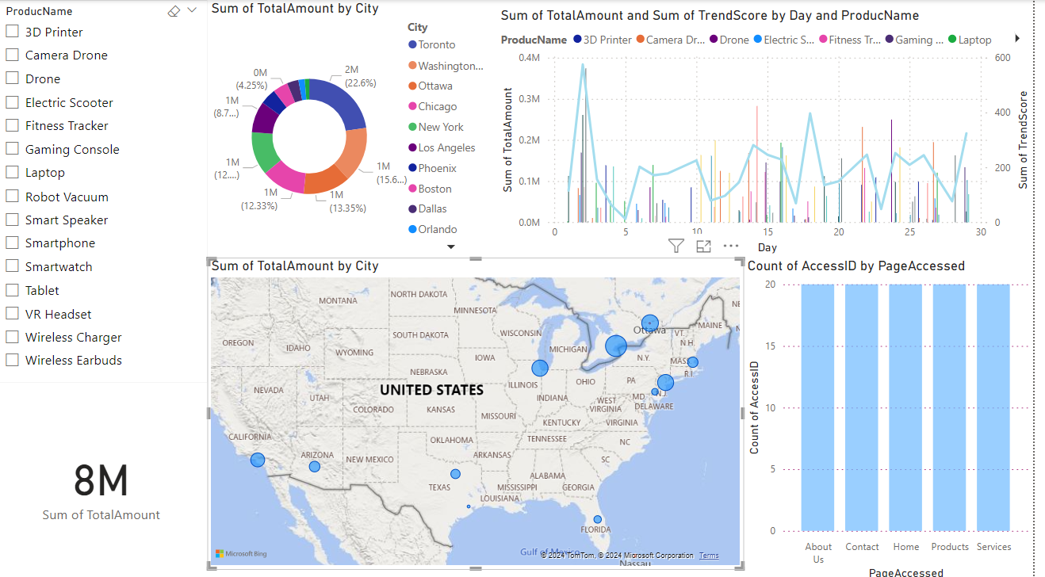

Figure 1: Power BI Dashboard

Donut Chart: Total Sales Amount by City:

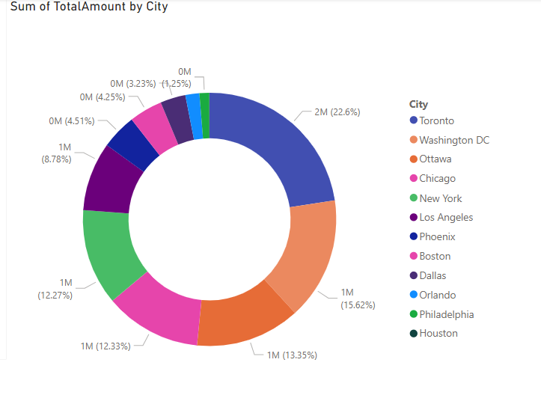

Figure 2: Donut Chart: Total Sales Amount by City

* Description: The donut chart displays the percentage of total sales amount by city.
* Analysis:
* Toronto: Holds the largest share with 22.6% of the total sales amount.
* Washington DC: The second-largest share with 15.62%.
* Ottawa: Contributes 13.35% of the total sales amount.
* Chicago: Has 12.33% of the total sales.
* New York: Accounts for 12.27% of the total sales.
* Los Angeles: Holds 8.78% of the total sales.
* Phoenix, Boston, Dallas: Each of these cities contributes between 4.25% to 4.51%.
* Orlando: Contributes 3.23%.
* Philadelphia: Has 1.25%.
* Houston: The smallest share with no significant sales contribution.
* Evaluate:
* Key Markets: Toronto, Washington DC, Ottawa, Chicago, and New York are the top five cities contributing significantly to the total sales. These cities should be the primary focus for sales and marketing efforts.
* Potential Markets: Los Angeles, Phoenix, Boston, Dallas, Orlando, and Philadelphia show moderate contributions, indicating room for growth with targeted efforts.
* Underperforming Market: Houston shows negligible sales, suggesting either a lack of market penetration or low demand.
* Business Strategy:
* Focus on Key Markets
* Intensify Marketing Efforts: Develop and implement intensive marketing campaigns targeting Toronto, Washington DC, Ottawa, Chicago, and New York. Tailor the marketing messages to the specific preferences and demographics of customers in these cities.
* Sales Promotions: Offer special promotions, discounts, and loyalty programs to boost sales further in these high-performing cities.
* Explore and Grow Potential Markets
* Targeted Campaigns: Create localized marketing strategies for Los Angeles, Phoenix, Boston, Dallas, Orlando, and Philadelphia to increase market share. These strategies can include local advertisements, community engagement, and partnerships with local businesses.
* Market Research: Conduct market research to understand the specific needs and preferences of customers in these cities. Use these insights to refine product offerings and marketing messages.
* Address Underperforming Markets
* Houston Strategy: Investigate the reasons behind the low sales in Houston. Conduct surveys and focus groups to understand the market barriers.
* Awareness Campaign: Increase brand awareness in Houston through targeted advertising and public relations efforts.
* Promotional Events: Host events and promotions to attract customers and increase visibility in the Houston market.
* By implementing these strategies and action plans based on detailed analysis from the Power BI dashboard, ABC Manufacturing can optimize its business processes, enhance customer satisfaction, and drive significant growth in revenue.

Line and clustered column chart: Total Sales Amount and Trend Score by Day and Product Name

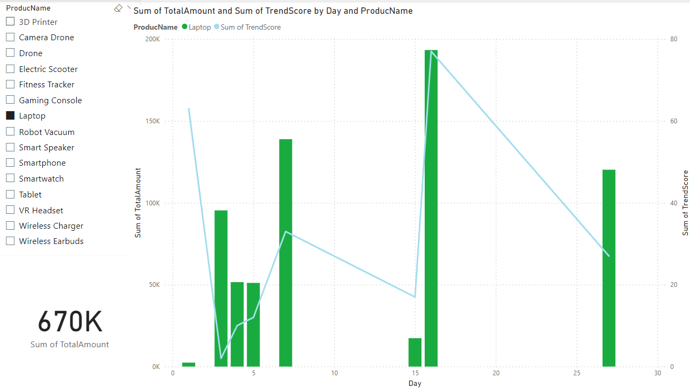

Figure 3: Line and clustered column chart

* Description
* **Column Chart (Green)**: Displays the total sales amount (Sum of TotalAmount) for the Laptop product by day.
* **Line Chart (Blue)**: Displays the trend score (Sum of TrendScore) for the Laptop product by day.
* Analysis of Total Sales Amount
* **Early Month (Days 1-7)**:
* Sales peak at the start of the month.
* High sales activity observed, potentially due to new month promotions or pay cycles.
* **Mid-Month (Days 8-14)**:
* Sales activity declines.
* Steady but lower sales compared to the start of the month.
* **Days 15-21**:
* Sales peak again, reaching the highest levels in the month.
* Potentially due to mid-month promotions or recurring customer purchase patterns.
* **Late Month (Days 22-30)**:
* Sales decline but see a slight increase towards the end of the month.
* Consistent but moderate sales levels.
* Analysis of Trend Score
* **Days 1-7**:
* Trend score is high at the start of the month.
* Indicates strong customer interest and engagement.
* **Days 8-14**:
* Trend score declines.
* Reflects decreased customer engagement or fewer promotional activities.
* **Days 15-21**:
* Trend score peaks again.
* Suggests successful promotional activities or increased customer interest.
* **Days 22-30**:
* Trend score decreases but stabilizes.
* Indicates moderate but steady customer engagement.
* Insights
* **High Sales Periods**: Early month and mid-to-late month show the highest sales and trend scores. These periods are likely driven by effective promotional activities or customer purchasing behaviors tied to specific times of the month.
* **Low Sales Periods**: Mid-month and late month show a decline in both sales and trend scores, indicating periods of lower customer activity.
* Business Strategy
* Enhance Promotions on High Sales Days
* Capitalize on high sales days by launching promotional campaigns, discounts, and special offers.
* Widely promote these campaigns through email marketing, online advertising, and social media.
* Address Low Sales Days
* Increase marketing and sales activities on low sales days to balance overall sales.
* Identify and address factors contributing to lower sales on these days.
* Stabilize Trend Score
* Create stability in the trend score by maintaining continuous marketing activities and developing long-term strategies.
* Use data to predict and adjust strategies to maintain stability in sales and trend scores.
* By analyzing the sales and trend score data by date range, ABC Manufacturing can optimize its promotional activities and marketing strategies. Focusing on high sales periods with targeted campaigns can boost overall revenue, while addressing low sales periods with special activities can balance sales throughout the month. Maintaining a stable trend score is crucial for sustainable growth, ensuring consistent customer engagement and interest in the laptop product. Implementing these strategies and action plans will help ABC Manufacturing achieve its sales targets and enhance customer satisfaction.

Stacked column chart: Count of AccessID by Page Accessed

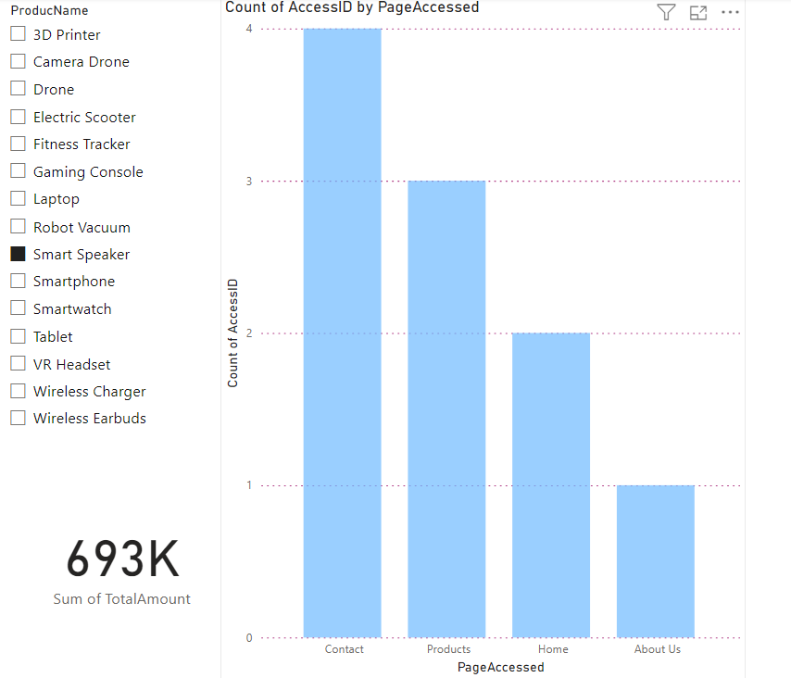

Figure 4: Stacked column chart: Count of AccessID by Page Accessed

* Description: Column: Displays the count of AccessID by the page accessed on the website for the product Smart Speaker.
* Data Points:
* Contact Page: 4 accesses
* Products Page: 3 accesses
* Home Page: 2 accesses
* About Us Page: 1 access
* Sum of TotalAmount: 693K (total sales amount for Smart Speaker)
* Analysis
* Page Access Insights
* Contact Page:
* Highest access count with 4 accesses.
* Indicates strong customer interest in reaching out for more information or assistance regarding the Smart Speaker.
* Products Page:
* Second highest access count with 3 accesses.
* Shows significant interest in detailed product information and features of the Smart Speaker.
* Home Page:
* Moderate access count with 2 accesses.
* Indicates general interest in the website and exploration of available products.
* About Us Page:
* Lowest access count with 1 access.
* Shows limited interest in the company background or mission when looking for Smart Speakers.
* Overall Insights
* High Interest in Contact and Products Pages: The higher access counts on these pages suggest that customers are particularly interested in obtaining detailed information about the Smart Speaker and seeking assistance or inquiries.
* Moderate Interest in Home Page: Indicates general exploration of the website but not as focused as the Contact and Products pages.
* Low Interest in About Us Page: Suggests that when customers are looking for Smart Speakers, they are less concerned with the company background and more focused on the product details and support.
* Business Strategy
* Enhance Contact and Customer Support Information
* Leverage the high interest in the Contact page by providing comprehensive and easily accessible contact information and customer support options.
* Ensure quick response times and high-quality support to address customer inquiries effectively.
* Provide Detailed Product Information and Promotion
* Enhance the Products page with detailed descriptions, high-quality images, videos, and customer reviews of the Smart Speaker.
* Highlight key features and benefits to attract and convert potential customers.
* Increase Engagement on Home and About Us Pages:
* Enhance the Home page to provide a more engaging and informative overview of the available products and services.
* Improve the About Us page to build trust and connect with customers on a personal level.
* The analysis of the access data for different web pages reveals valuable insights into customer interests and behaviors. The high access count for the Contact and Products pages suggests a strong focus on obtaining detailed product information and customer support. Enhancing these pages with comprehensive information and high-quality support can further attract and retain customers. Additionally, improving engagement on the Home and About Us pages can provide a better overall customer experience and strengthen the company's brand image. Implementing these strategies and action plans will help ABC Manufacturing optimize its online presence, increase customer satisfaction, and drive sales growth for the Smart Speaker.

1. Evaluation of the Wider Implications of Using Data and Information to Support Business Processes in ABC Manufacturing
2. Positive Implications

Operational Efficiency

* Data-Driven Decision-Making: Utilizing data from Power BI, ABC Manufacturing can streamline processes and optimize resource allocation.
* Example: By analyzing sales trends over time, the company can adjust production schedules to align with peak demand periods, reducing downtime and improving efficiency.
* Resource Optimization: Power BI's inventory management visuals help allocate resources effectively, ensuring that high-demand areas are well-stocked while minimizing excess inventory in low-demand regions.
* Example: Using the map visual to monitor sales by city allows for dynamic inventory adjustments, reducing the need for expensive warehousing and minimizing stockouts.

Improved Decision-Making

* Accurate and Timely Data: Access to real-time data in Power BI enables informed decision-making, leading to better outcomes and reduced risks.
* Example: The line chart showing sales trends helps forecast demand accurately, allowing for proactive adjustments in production and inventory management.
* Comprehensive Insights: Integrating data from various sources into a unified Power BI dashboard provides a holistic view, supporting strategic planning and risk management.
* Example: Combining sales data with customer access metrics helps identify popular products and target marketing efforts effectively.

Enhanced Customer Experience

* Understanding Customer Preferences: Analyzing page access data reveals customer interests, enabling personalized marketing and improved customer engagement.
* Example: High access counts on the Services and Products pages indicate areas of interest, guiding the focus of marketing campaigns and customer support enhancements.
* Personalized Experiences: Tailoring product availability and promotions based on customer behavior enhances the shopping experience, leading to increased satisfaction and loyalty.
* Example: Targeted promotions during peak sales periods identified in Power BI can drive customer engagement and repeat purchases.

Competitive Advantage

* Market Trends and Customer Demands: Leveraging data to identify market trends and predict customer demands helps ABC Manufacturing adapt its strategies and gain a competitive edge.
* Example: Analyzing sales data by city and product allows the company to focus on high-demand regions and products, outperforming competitors who lack such insights.
* Strategic Insights: Using Power BI to track and analyze key performance indicators (KPIs) supports strategic decision-making and long-term planning.
* Example: Real-time sales and inventory data enable quick adjustments to marketing strategies and inventory levels, keeping the company ahead of market changes.

Cost Savings

* Supply Chain Optimization: Data analysis in Power BI helps optimize supply chain processes, reducing waste and improving resource utilization.
* Example: Monitoring sales by region and adjusting inventory levels accordingly reduces excess stock and lowers storage costs.
* Efficient Resource Allocation: Using data to streamline operations and minimize inefficiencies results in significant cost savings.
* Example: Accurate demand forecasting minimizes overproduction and underproduction, reducing production costs and waste.

1. Negative Implications

Data Overload

* Over-Analysis: Too much data can lead to over-analysis, hindering decision-making processes and causing delays.
* Example: Sifting through excessive data without clear focus can slow down decision-making and lead to missed opportunities.
* Complexity: Managing and interpreting large volumes of data can be complex and time-consuming.
* Example: Integrating and analyzing data from multiple sources in Power BI requires skilled personnel and significant time investment.

Implementation Costs

* Initial Setup and Maintenance: Establishing and maintaining data analytics systems like Power BI can be expensive.
* Example: Investing in Power BI infrastructure, training, and ongoing maintenance requires significant financial resources.
* Resource Allocation: Allocating resources for data management and analysis may divert funds from other critical areas.
* Example: High initial costs for setting up data analytics may impact budgets for marketing or product development.

Dependence on Technology

* Over-Reliance on Data: Excessive dependence on data and analytics can overshadow intuitive judgments and decisions based on experience.
* Example: Solely focusing on data trends without considering market conditions and expert intuition can lead to missed opportunities.
* Risk of Technical Issues: Technical failures or errors in data analytics systems can disrupt business operations.
* Example: Downtime or inaccuracies in Power BI can lead to poor decision-making and operational disruptions.

Security Risks

* Data Breaches: Increased data collection and storage heighten the risk of data breaches and cyberattacks.
* Example: Storing vast amounts of customer and sales data increases the vulnerability to cyber threats, requiring robust security measures.
* Regulatory Compliance: Ensuring compliance with data protection regulations can be challenging and resource intensive.
* Example: Adhering to GDPR or other data protection laws requires continuous monitoring and compliance efforts.

1. Consequences of Failure to Protect Data Adequately

Loss of Customer Trust

* **Breach of Privacy**: Failure to protect customer data can lead to breaches of privacy, damaging the company's reputation and eroding customer trust.
* **Example**: A data breach exposing customer information can result in loss of customer loyalty and negative publicity.

Financial Penalties

* **Regulatory Fines**: Non-compliance with data protection regulations can result in significant financial penalties.
* **Example**: Violations of GDPR can lead to substantial fines, impacting the company's financial health.

Legal Consequences

* **Lawsuits**: Data breaches can lead to lawsuits from affected customers, resulting in legal expenses and settlements.
* **Example**: Customers whose data was compromised may file lawsuits for damages, leading to costly legal battles.

Operational Disruptions

* **Business Interruptions**: Data breaches and security incidents can disrupt business operations, causing financial losses and operational inefficiencies.
* **Example**: Downtime due to a cyberattack can halt production and sales, leading to revenue loss and increased recovery costs.
* The use of data and information to support business processes in ABC Manufacturing has significant positive implications, including improved operational efficiency, better decision-making, enhanced customer experience, competitive advantage, and cost savings. However, there are also negative implications, such as data overload, implementation costs, dependence on technology, and security risks. Failure to protect data adequately can have severe consequences, including loss of customer trust, financial penalties, legal issues, and operational disruptions. By leveraging Power BI for data analysis and implementing robust data security measures, ABC Manufacturing can maximize the benefits of data-driven decision-making while mitigating associated risks.

1. Conclusion

The use of data and information to support business processes in ABC Manufacturing has brought about significant positive impacts, including improved operational efficiency, enhanced decision-making capabilities, better customer experiences, a competitive advantage, and substantial cost savings. By leveraging tools like Power BI, the organization has been able to accurately forecast demand, optimize inventory management, and gain valuable insights into customer preferences and behaviors.

However, the adoption of data-driven processes is not without its challenges. Issues such as data overload, high implementation and maintenance costs, reliance on technology, and security risks need to be carefully managed. Failure to adequately protect data can lead to severe consequences, including loss of customer trust, financial penalties, legal complications, and disruptions in business operations.

To maximize the benefits of data-driven decision-making while mitigating these risks, it is crucial for ABC Manufacturing to invest in robust data security measures and employee training. By ensuring the protection of sensitive information and empowering staff with the skills to effectively utilize data analytics tools, the organization can continue to leverage its data assets to drive growth, improve customer satisfaction, and maintain a competitive edge in the market.

In summary, while the integration of data and information into business processes offers numerous advantages, it requires careful planning and management to address potential challenges and ensure the security and integrity of the data. With the right strategies and tools in place, ABC Manufacturing can harness the power of data to achieve sustainable success and growth.

1. Reference list

* www.sweephy.com. (n.d.). *What is data in business? and its importance*. [online] Available at: <https://www.sweephy.com/blog/what-is-data-in-business-and-its-importance>.
* Sirianni, A. (2023). *The Importance of Data and Information in Business - Blog - DCODE GROUP - DCODE GROUP*. [online] DCODE GROUP: Custom Software Development - Melbourne, Australia. Available at: https://dcodegroup.com/blog/the-importance-of-data-and-information-in-business.